Presentation Speech Guide
AI-Powered Customer Support Triage
A complete, timed script for the 7-minute talk + 3-minute Q&A
Ryan Mwangi • n8n Workflow Automation — Final Capstone • June 2026

How to use this guide
This guide is your full script. Each section gives you three things:
- SAY (blue bar) — the words to speak. You can read these almost verbatim, or paraphrase in your own voice.
- SHOW (green) — what to have on screen at that moment.
- TIP (amber) — delivery reminders and things to emphasise.
Total speaking time is engineered for 7 minutes. The time range at the start of each section is your pacing guide. Rehearse once out loud with a timer — if you run long, the Live Demo is the section to trim.
TIP: Breathe between sections. Pause for one second after each big number or before each 'why'. Confidence comes from pacing, not speed.

Presentation Directory (agenda & timing)
# | Section | Time | Running total
1 | Hook + what the system is | 0:40 | 0:40
2 | The business problem + original design | 1:00 | 1:40
3 | Weaknesses: where it could fail | 1:00 | 2:40
4 | The upgrades (the core) | 2:50 | 5:30
5 | Live demo / walkthrough | 1:10 | 6:40
6 | Why it is more robust + close | 0:20 | 7:00
Q&A | Anticipated questions + answers | 3:00 | 10:00

1. Hook + what the system is

[0:00 - 0:40] Open with the stakes, then the one-sentence summary
Imagine a customer emails you furiously: they've been charged twice and locked out of their account, and a meeting starts in an hour. Now imagine that email sitting unread behind forty 'how do I change my profile picture' tickets. That is the problem this project solves.
I built an AI-powered customer-support triage system in n8n. It automatically reads every incoming ticket, cleans the data, decides how urgent it is, drafts a reply, logs everything, and escalates the genuinely urgent cases to a human in seconds — around the clock.
SHOW: Title slide, or the Workflow 1 canvas.
TIP: Slow down on the opening story. That single furious customer is your emotional anchor — come back to them in the demo.

2. The business problem + the original design

[0:40 - 1:40] What I started with, and what worked
In Week 8 I built the first version. It was a single line of nodes: a webhook started it, it read tickets from a Google Sheet, two AI agents processed them — a 'Janitor' that cleaned the category and a 'Triage Officer' that set urgency and drafted a reply — then a Code node parsed the AI's text, an IF node checked urgency, and urgent ones triggered an email.
And honestly? In a clean demo, it worked. The AI classified tickets correctly and the urgent email fired. It looked finished.
But it made three quiet assumptions: that the AI would always return perfectly formatted text, that the APIs would always be up, and that nothing would ever go wrong mid-run. In the real world, all three of those assumptions break.
SHOW: A diagram or screenshot of the simple original flow (or describe it).
TIP: Say 'it looked finished' with a small pause — it sets up the twist that it wasn't.

3. Weaknesses: where it could fail

[1:40 - 2:40] Be honest and specific — this earns credibility
When I stress-tested it, I found five weaknesses. The worst one was almost invisible. The node that logged tickets to the sheet was wired AFTER the urgent-email step, on the 'urgent' branch only. That meant every medium and low priority ticket — the majority — was silently dropped and never logged. The system looked like it was working while quietly losing most of its data. That is the most dangerous kind of bug.
The other four: the AI output was parsed by hand, so one stray character would crash the whole run. Only one of the two agents had a backup model. There were no retries, no error handling, and no way to continue if one ticket failed. And there was no logging or audit trail at all — it was a black box. You couldn't debug it, trust it, or sell it.
SHOW: Optional: the 'weaknesses' table from the documentation, or just speak it.
TIP: Land the silent-data-loss bug hard — pause after 'silently dropped'. This is the most memorable moment of your talk.

4. The upgrades — the core of the talk

[2:40 - 5:30] Five upgrades. State what, then WHY it is better.
Cover all five. For each, say what you built and — crucially — why it makes the system more robust.

4a. Structured AI output (~35s)
First, I made the AI output predictable. Instead of hoping the model returns clean text and parsing it by hand, each agent now has a Structured Output Parser bound to a strict JSON schema. The category can only ever be Billing, Technical, or General; urgency can only be High, Medium, or Low. Why it's better: the AI is now forced into a valid shape, so a stray word can never crash the pipeline again. The output is guaranteed machine-readable.
SHOW: Janitor or Triage Officer node — the JSON schema (Edit Input Schema) and the clean OUTPUT object.

4b. Fault tolerance (~35s)
Second, fault tolerance. Every AI agent and every Google Sheets node now retries automatically — three times, with a short wait — so a momentary network or API blip just retries instead of failing. And I turned on continue-on-error in the right places, so if one bad ticket fails, it's set aside and the rest of the batch keeps processing. Why it's better: one bad row, or one flaky moment, can no longer take down the entire run.
SHOW: Any node's Settings tab — Retry On Fail and 'Continue (using error output)'.

4c. Model fallbacks (~35s)
Third, model fallback. Each agent uses Groq's Llama 3.3 as its primary model, and Mistral Large as an automatic fallback. If Groq is down or rate-limited, the agent silently switches to Mistral and keeps going. Why it's better: because the two providers are completely separate companies, a single provider outage can't stop my system. I actually saw this fire live during testing when I hit Groq's rate limit.
SHOW: The two model nodes (Groq Primary + Mistral Fallback) wired under one agent.
TIP: This is a strong, concrete story — mention you hit the real rate limit and the fallback caught it.

4d. Logging & governance (~35s)
Fourth, logging and governance. I moved the logging step BEFORE the urgency branch, so now every single ticket is recorded — fixing that silent data-loss bug — along with which AI model handled it and a timestamp. And I built a dedicated error-handling workflow: any failure anywhere is automatically caught, written to an ErrorLog with full context and a link to the failed run, and emailed to the team. Why it's better: the system went from a black box to fully observable. Nothing fails silently anymore.
SHOW: TriagedTickets sheet (every ticket logged) and the ErrorLog sheet.

4e. Architecture & human-in-the-loop (~30s)
Finally, I split the system into three clean workflows — data processing, error handling, and human response — so each part is independently testable and reusable. And one deliberate design choice: the customer reply is never sent automatically. The AI's draft is saved to Gmail for a human to review and approve. Why it's better: a person stays in control of anything a customer actually sees — which is the safe, professional choice for a real product.
SHOW: Workflow 3 canvas, and the Gmail draft sitting in the Drafts folder.

5. Live demo / walkthrough

[5:30 - 6:40] Small, safe, rehearsed. Narrate as it runs.
Let me show it running. I'll send in a batch of tickets — including our furious double-charge customer from the start. Watch the pipeline: it reads them, the Janitor cleans the categories — see this messy 'billingg' becomes a clean 'Billing' — the Triage Officer sets urgency and drafts replies, every ticket gets logged here, and the urgent ones get escalated. And here in Gmail: the team alert is sent, and the customer reply is waiting as a draft for a human to approve.
SHOW: Run Workflow 1 with a small batch (3-5 tickets, one urgent). Then show TriagedTickets + the Gmail draft.
TIP: Use a SMALL batch (3-5) so you never hit a rate limit on stage. If the network is risky, fall back to showing pre-captured screenshots — the run is optional.
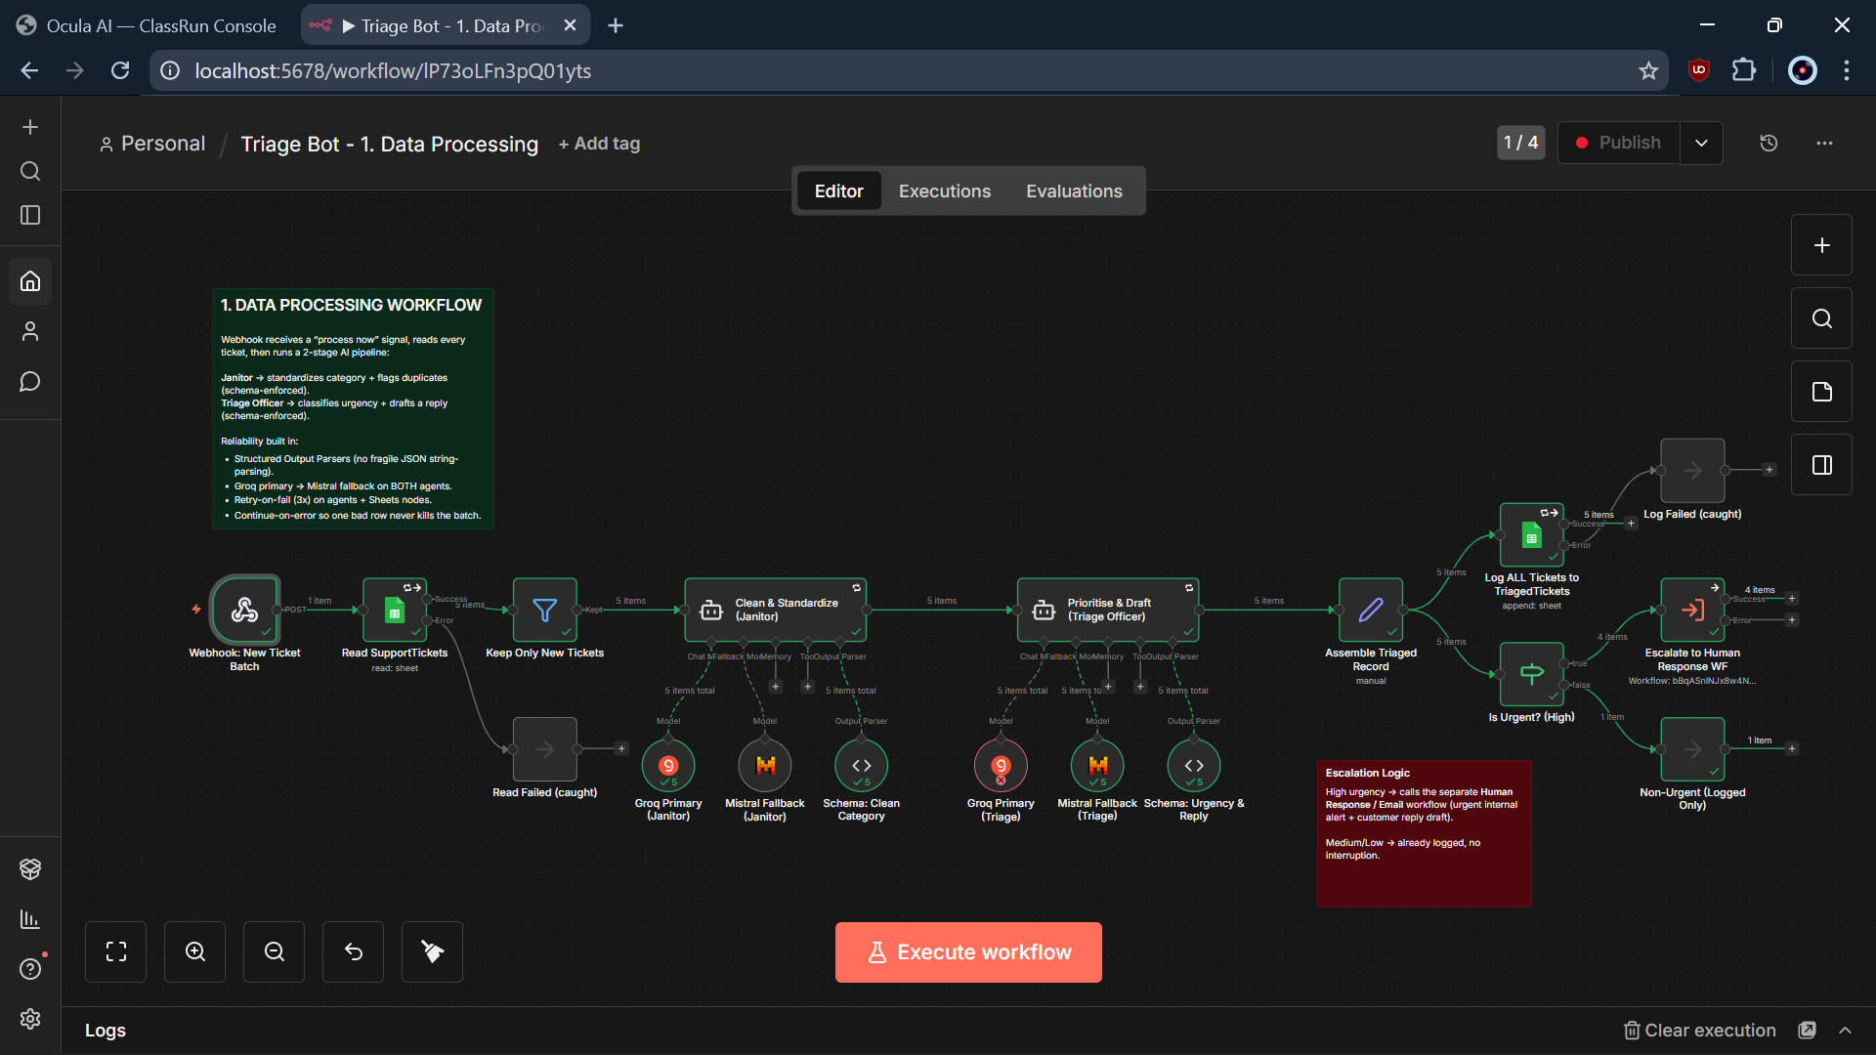
Workflow 1 — the pipeline you will run
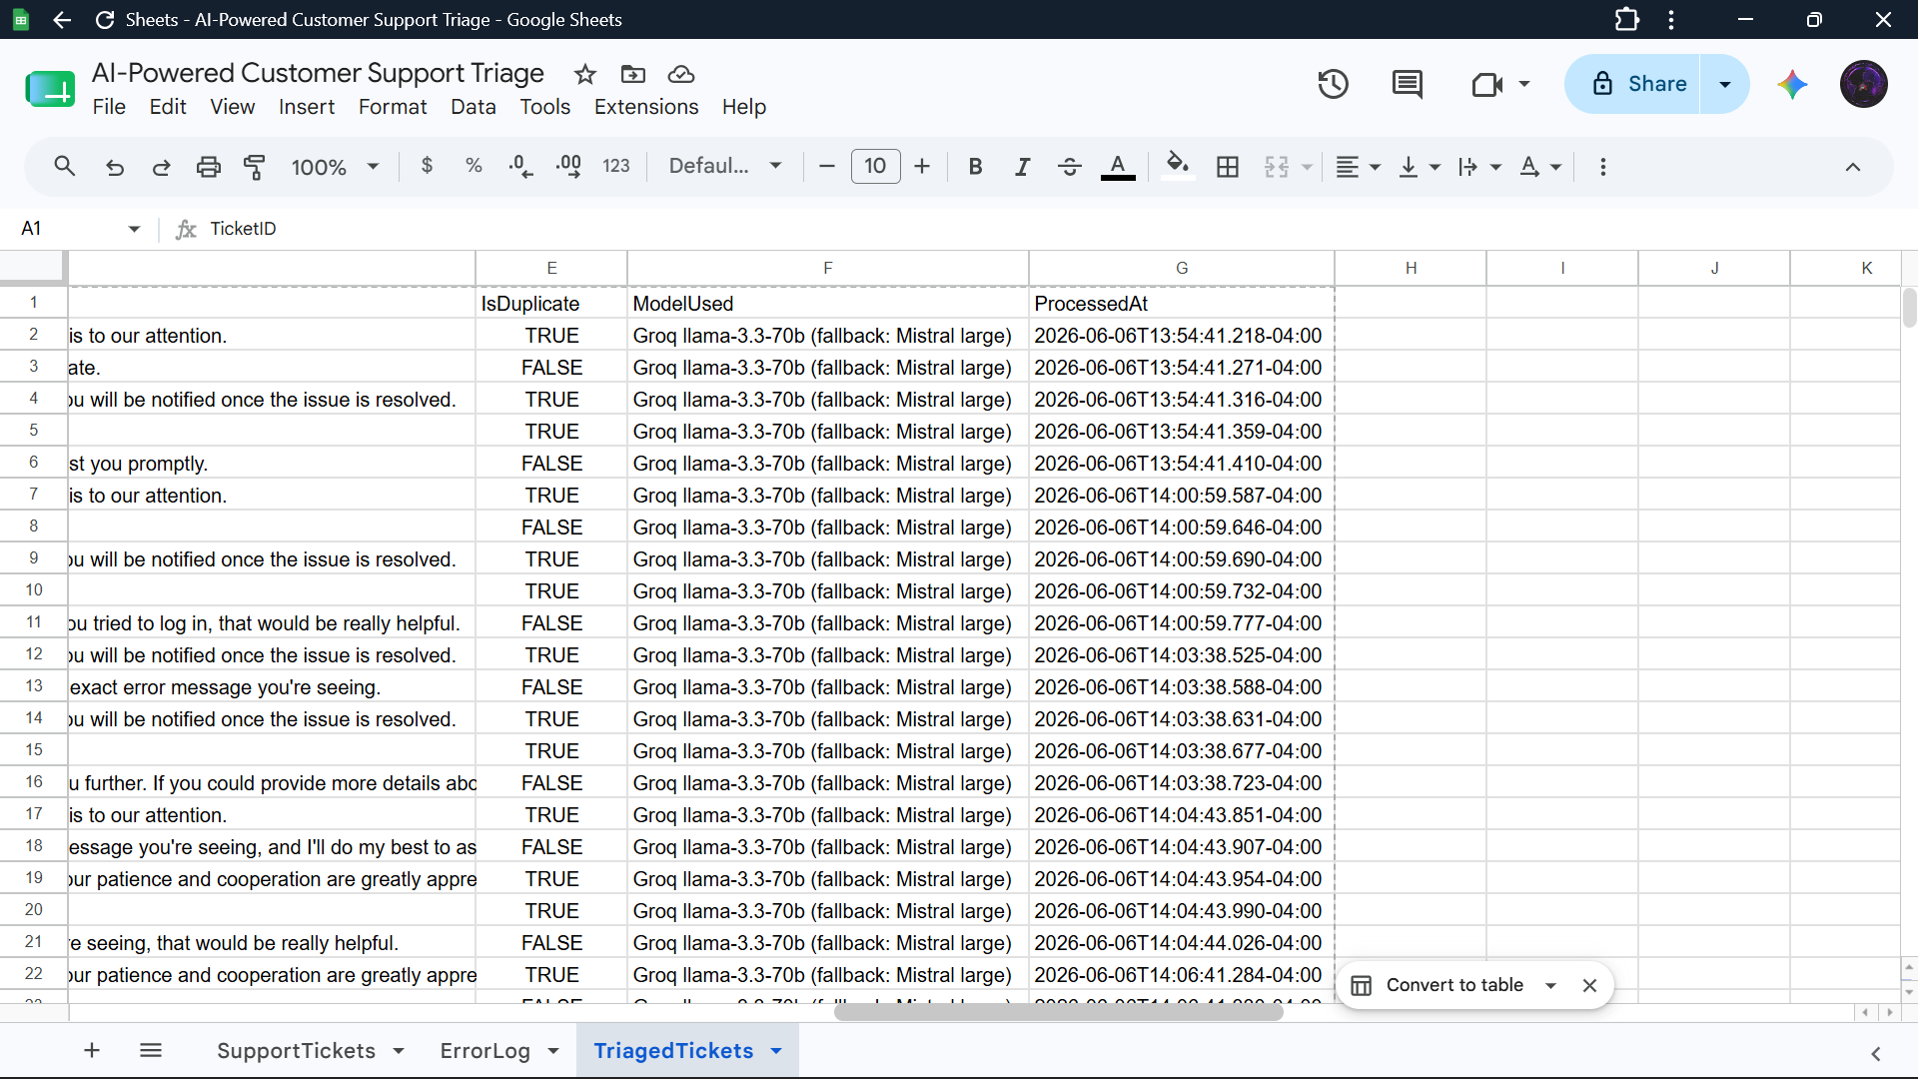
TriagedTickets — every ticket logged, with model + timestamp

6. Why it is more robust + close

[6:40 - 7:00] One clean closing line.
So the original looked like it worked, but it quietly lost data and would die at the first hiccup. The new version is observable, resilient, predictable, and safe. It went from a demo to something you could actually run a real support desk on. Thank you — I'm happy to take questions.
TIP: Memorise the last two sentences word-for-word. Finish looking up at the room, not at the screen.

Q&A Preparation
Likely questions with strong, concise answers. Keep each answer to 20-30 seconds.
Q1. What happens if BOTH Groq and Mistral are down at the same time?
A. Then the fallback can't help — that's an honest limitation. The agent retries three times, and if it still fails, the error-handling workflow logs it and alerts the team, so it fails loudly, not silently. The next step would be a third provider or a queue that retries later.
Q2. Why did you save the customer reply as a draft instead of sending it?
A. Human-in-the-loop safety. The AI is good, but anything a customer actually receives should have a human's eyes on it. Drafting keeps speed for the team while a person clicks send — the right trade-off for a real, sellable product.
Q3. How exactly do you enforce structured output?
A. Each agent has a Structured Output Parser node bound to a JSON schema with enums — category is locked to three values, urgency to three values. n8n forces the model's output to match that schema, so downstream nodes read typed fields instead of parsing free text.
Q4. Why three separate workflows instead of one?
A. Separation of concerns. Data processing, error handling, and human response each change for different reasons. Splitting them makes each independently testable and reusable, and lets the error workflow act as a global safety net for the others.
Q5. What was the single biggest improvement?
A. Fixing the silent data-loss bug by logging every ticket before the urgency branch. The original only logged urgent tickets — it was quietly throwing away most of the data while appearing to work.
Q6. How does the error workflow know when to escalate?
A. It reads the error message. If it contains auth, credential, quota, rate-limit, or codes like 401/403/429, it's marked HIGH and triggers an urgent escalation email; everything else gets a standard notification. Both are logged either way.
Q7. What does this cost to run?
A. On free tiers, effectively nothing — Groq and Mistral both have generous free tiers. At production volume you'd move to paid tiers; Mistral Large is about $2 per million input tokens. The Groq free tier allows roughly 30 requests a minute and 1,000 a day.
Q8. How do you handle rate limits?
A. Three layers: retry-on-fail absorbs short bursts, the Groq-to-Mistral fallback covers a single provider being throttled, and for production you'd pace requests or upgrade tiers. I actually hit Groq's limit during testing and watched the fallback engage.
Q9. Is the duplicate detection reliable?
A. It's a per-ticket heuristic right now, so it's indicative rather than authoritative. To make it solid I'd add a shared store of recent tickets so the AI can compare across the whole batch.
Q10. Could this scale to thousands of tickets a day?
A. The architecture scales; the limiter is the AI rate limits. With paid API tiers and batching, yes. n8n itself handles the orchestration comfortably.

One-Page Cheat Sheet
Glance at this right before you go on.

The five upgrades (memorise the order)
- Structured output — JSON schema, enum-locked, no crashes.
- Fault tolerance — retry 3x + continue-on-error.
- Model fallback — Groq -> Mistral, cross-provider.
- Logging & governance — log every ticket + ErrorLog + alerts.
- Architecture — 3 workflows; customer reply = human-approved draft.

Key facts & numbers
- Primary model: Groq llama-3.3-70b. Fallback: Mistral large.
- Retries: 3 attempts, 2-second backoff.
- Categories: Billing / Technical / General. Urgency: High / Medium / Low.
- 3 sheets: SupportTickets (in), TriagedTickets (log), ErrorLog (errors).
- Groq free tier: ~30 req/min, ~1,000 req/day (use small demo batches).

The headline line
"The original looked like it worked, but it quietly lost data and would die at the first hiccup. The new version is observable, resilient, predictable, and safe."

